APPLICATION TO MAKE THE GAS FILLING STATION EASY USING CRM (DEVELOPER)

ABSTRACT
Managing customer interactions and operations efficiently is one of the biggest challenges for any business, and gas filling stations are no exception. This project uses Salesforce CRM to
design a custom application that helps streamline the gas filling process. By creating objects such as Buyers, Fuel Details, Gas Stations, and Suppliers, the system can record and organize essential information in one place.
With page layouts and sections like personal details, vehicle information, and receipt details, customer data becomes easier to handle, making the overall process more transparent and
reliable. In addition to data management, the project also focuses on user roles, profiles, and permissions to ensure smooth collaboration between managers, sales executives, and
salespersons.
Features like session management, password policies, and access levels strengthen security, while the structured roles make responsibilities clear. Altogether, this application
demonstrates how Salesforce CRM can be adapted for a real-world business case, making
daily operations simpler for employees and improving the customer experience at gas filling stations.

OBJECTIVE
The Gas Filling Station CRM project is designed with a clear vision to improve both customer service and store management. Its objectives are focused on simplifying operations, ensuring data security, and creating a smooth experience for all stakeholders.
- Streamline Operations: Manage customer, fuel, supplier, and station details in one CRM platform.
- Enhance Customer Experience: Keep accurate records of customer details, vehicles, and receipts.
- Role-Based Access: Assign secure roles like Manager, Executive, and Salesperson.
- Improve Efficiency: Minimize manual work and human errors by automating routine tasks like managing buyer details, fuel entries, and payment transactions.
- Ensure Data Security: Protect sensitive data with policies and permissions.
- Enable Scalability: Support future needs like reports and dashboards.

TECHNOLOGY DESCRIPTION

Salesforce:
A cloud-based CRM platform used to manage customer relationships, streamline operations, and securely store data. It provides tools for creating custom objects, automation, user roles, and reporting.

Custom objects:
These Objects in Salesforce are user-defined database tables used to store information specific to a business. They allow you to create fields, relationships, and layouts to manage and organize data unique to your organization.

Tabs:
Tabs in Salesforce are user interface elements that provide easy access to objects, apps, or web pages. They allow users to quickly navigate and work with custom or standard objects within a Lightning App.

Lightning App:
An app is a collection of items-such as objects, tabs, and utilities-bundled together to serve a specific function. It provides a branded, user-friendly interface that allows employees to access and switch between related objects and tools efficiently.

Page Layouts:
Fields and sections are organized on a record page to make data entry easier, more structured, and user-friendly.

Profiles:
Define user permissions and access in Salesforce, determining what objects, fields, and features a user can view or modify.

Roles and hierarchy:
Control record-level access, defining who can see or act on data based on their position in the organizational structure.

Users:
These are individual accounts that allow people to log in and access the system, with permissions and roles assigned based on their profiles and responsibilities.

Permission sets:
Grant additional access rights to users without changing their profiles, allowing flexible, role- based permissions for specific objects or actions.

Organization-Wide Defaults (OWD):
Define the baseline level of access users have to records they do not own, ensuring data security and controlled visibility across the organization.

Reports and dashboards:
Provide visual insights and summaries of business data, helping users track performance, analyse trends, and make informed decisions.

Flows:
Automate business processes by collecting, updating, and managing data, allowing tasks to run automatically based on record changes or user actions.

Apex triggers:
These are custom codes that execute before or after specific events on records, automating complex business logic like validations, updates, or notifications.

Project Implementation Steps

Setting Up a Salesforce Developer Org:

  - Sign up for a Developer Org with your details using https://developer.salesforce.com/signup
  - Verify your email, set a password, and access the setup page.

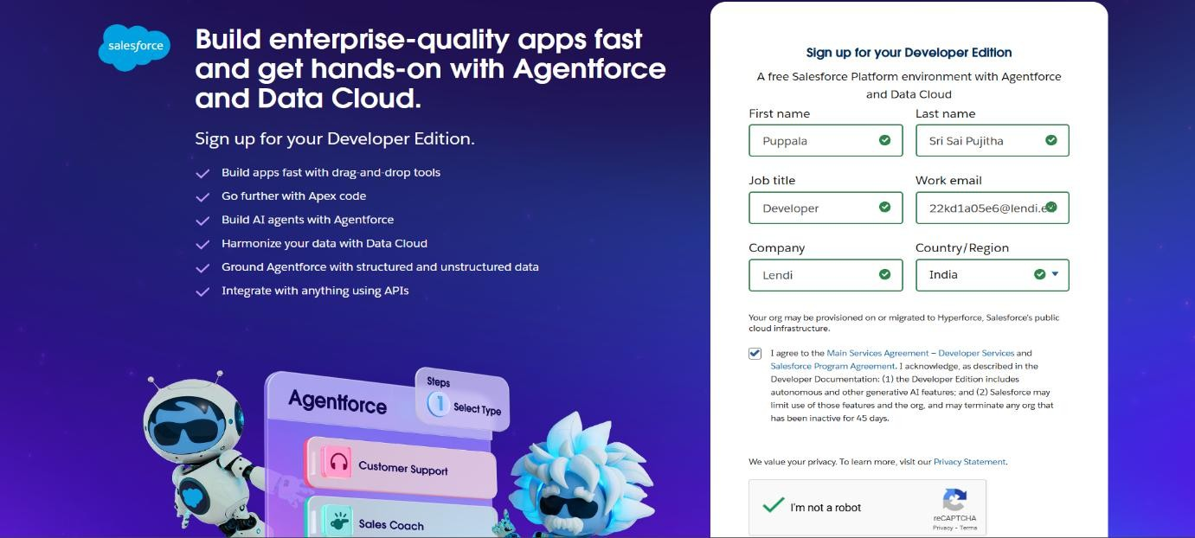

Activation through the salesforce developer mail

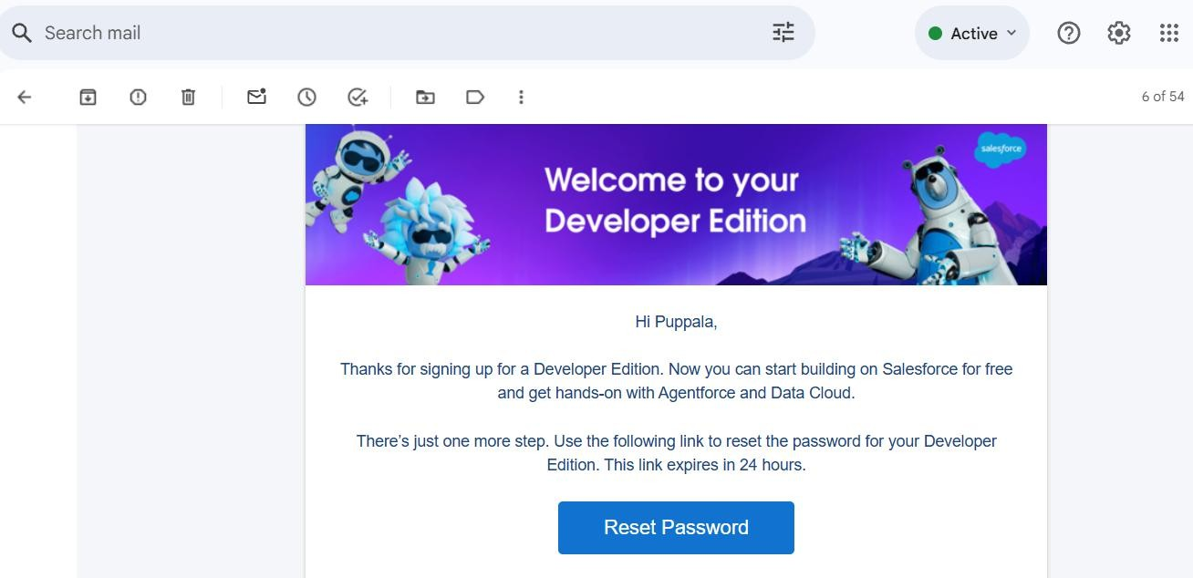

Custom Objects Creation:

Procedure for Object Creation:
Defines the method of setting up custom objects in Salesforce, including naming, data type selection, and enabling reporting and field tracking.

Four custom objects:
  - Buyer c: Stores customer details and manages their fuel purchases.
  - Fuel_details c: Records fuel transactions linking buyers, suppliers, and gas stations.
  - Gas_Station c: Maintains gas station information, fuel availability, and usage.
  - Supplier c: Tracks suppliers and the total fuel supplied to stations.
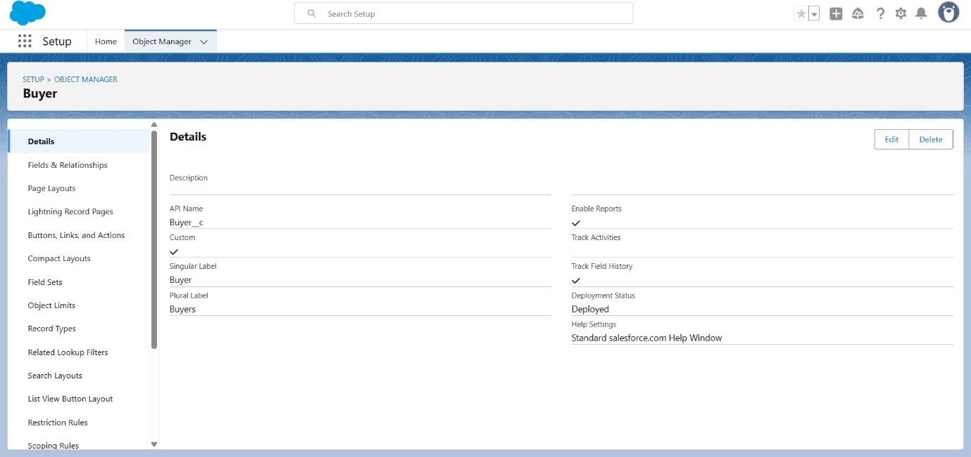

Custom Tabs:

Represents a way to access Salesforce objects easily.
  - Tabs are created for each custom object - Buyer, Fuel Details, Gas Station, and Supplie- allowing users to navigate and manage records efficiently within the Lightning App.
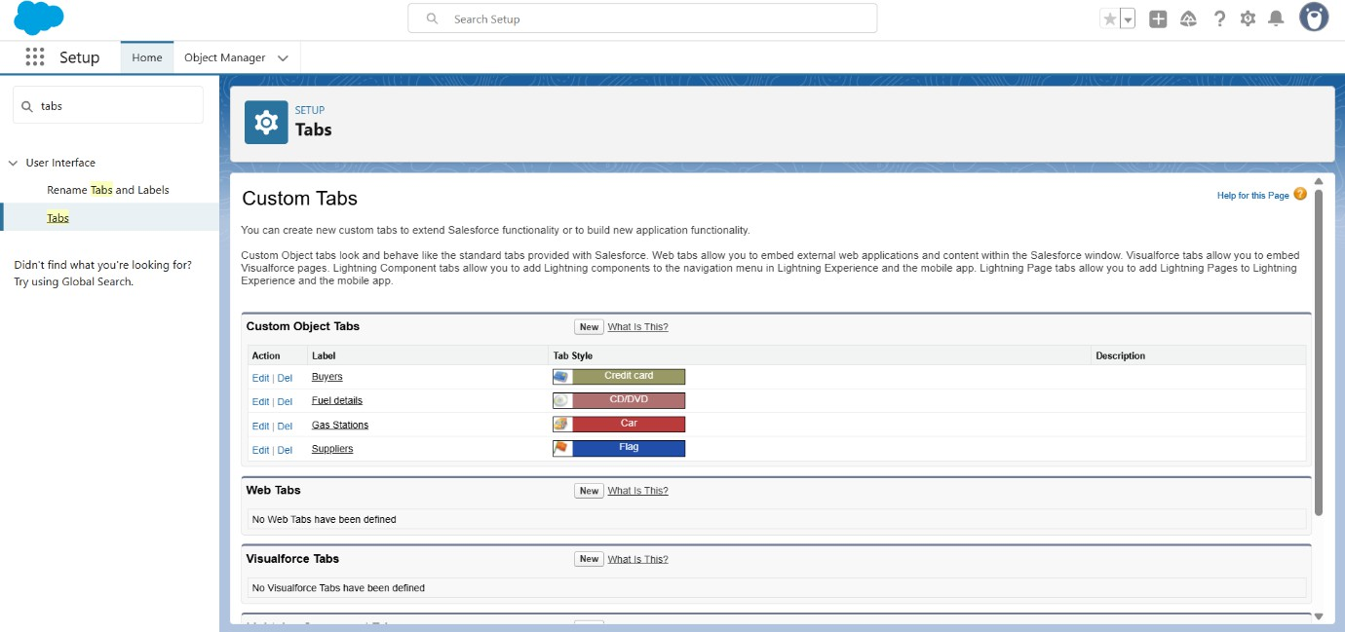

Create Lightning App:

Created Gas Station App for managing CRM operations. Configured with required custom objects for smooth usage.
  - Created Lightning App “GAS STATION”.
  - Assigned to System Administrator profile.
  - Created objects:
    - Buyer
    - Fuel Details
    - Gas Station
    - Supplier
and added necessary fields to each for managing the Gas Station CRM.

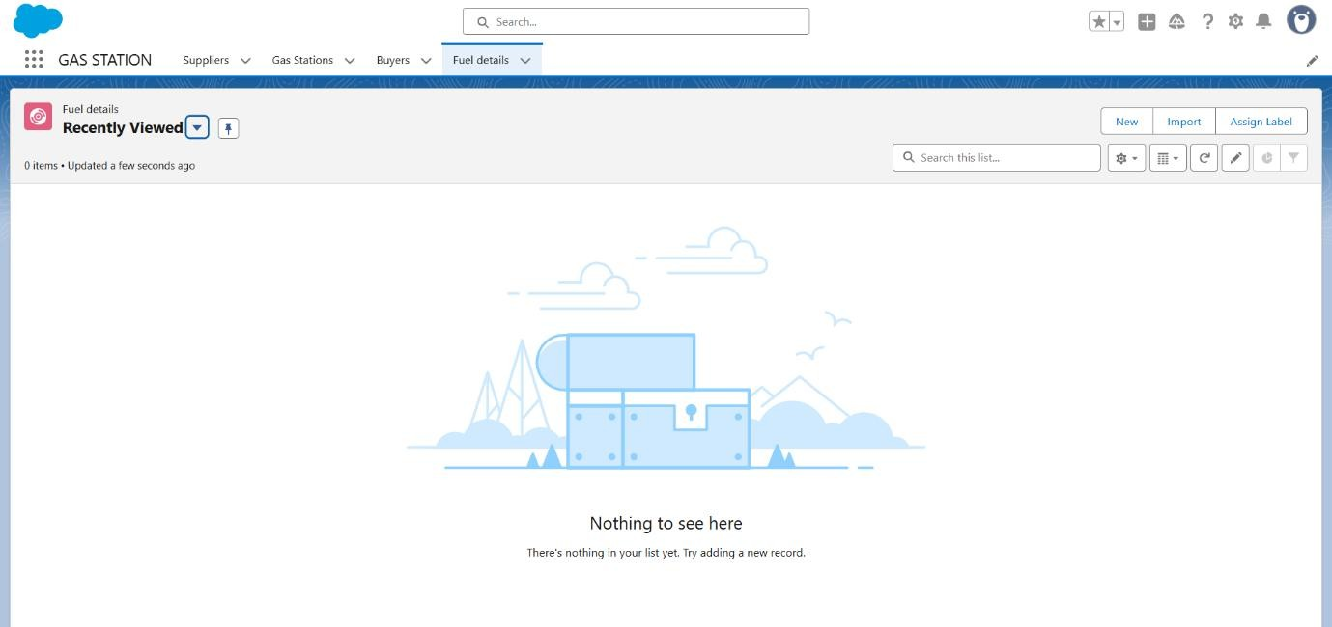

Fields to be created:

  - Buyer c: First Name, Last Name, Customer Name (Formula), Phone Number,
Email, Vehicle Type (Picklist), Fuel Filled in Vehicle, Mode of Payment (Picklist), Amount Paid (Formula)
Validation in buyer object (phone number)

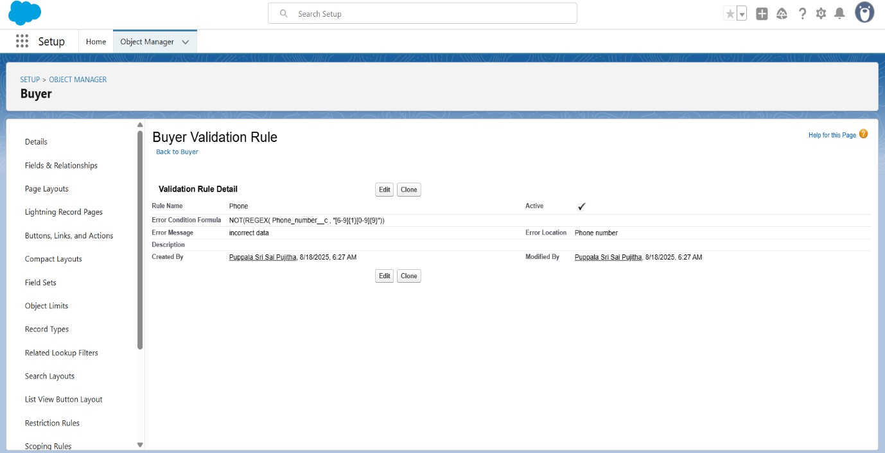

  - Fuel_details c: Fuel Supplied (Number), Supplier Name (Master-Detail), Gas Station (Master-Detail)
  - Gas_Station c: Fuel Price per Liter (Number), Fuel Supplied to Bunk (Roll-up Summary), Fuel Used (Roll-up Summary), Fuel Available in Bunk (Formula)
  - Supplier c: Sum of Fuel Supplied (Roll-up Summary)

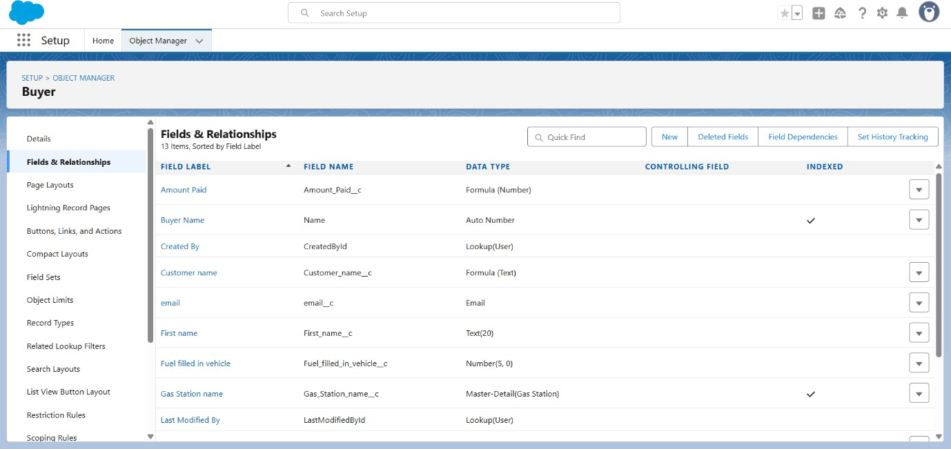

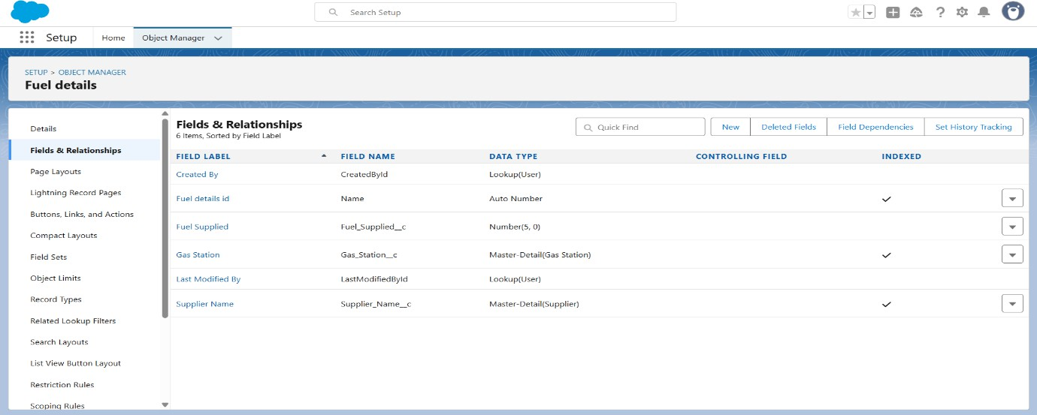

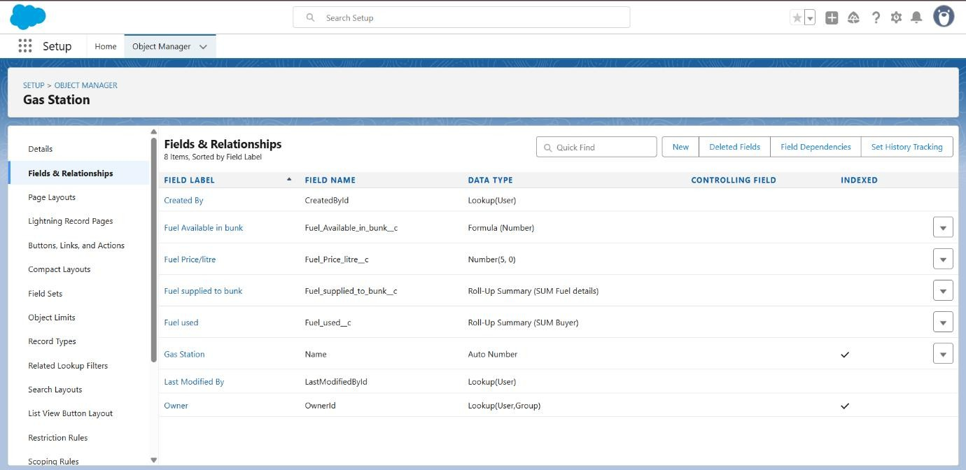

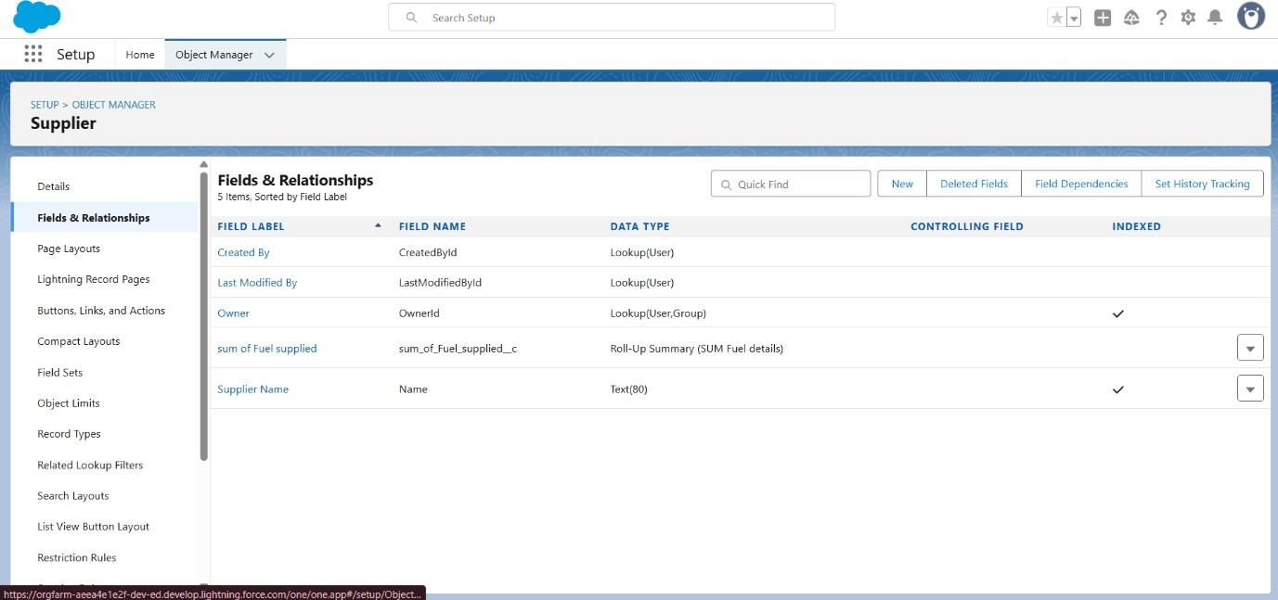

Create Page Layout for Objects:

Created page layouts for objects, organized sections, and arranged fields for better usability.
  - Go to Setup → Object Manager → [Object] → Page Layouts → New.
  - Create sections as needed and drag relevant fields into each section.
  - Arrange fields for clear organization and improved usability.
  - Click Save to apply the layout across the object.

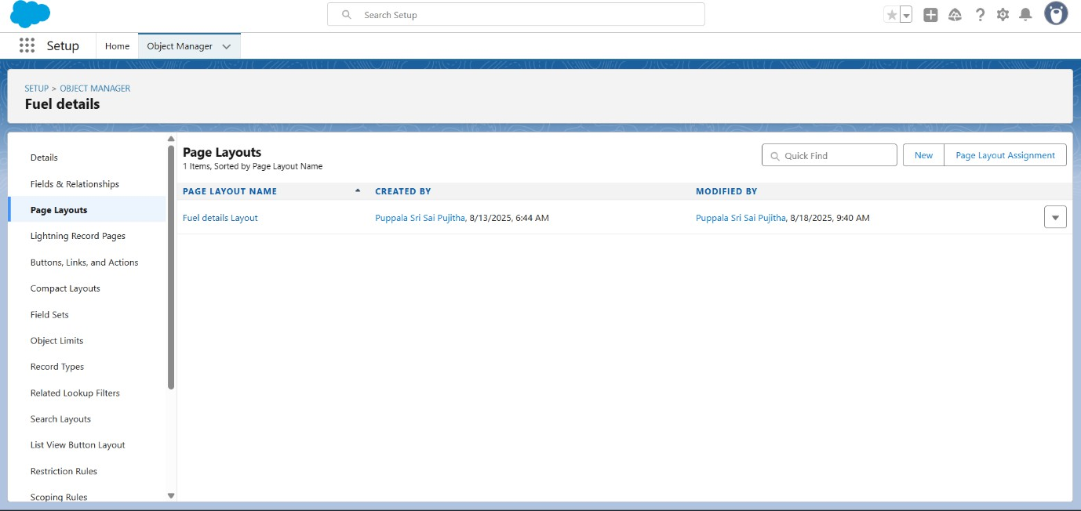

Create Profiles:

Profiles ensure proper access control and define what data/actions each role can perform. They also help in maintaining security and restricting unnecessary access.
  - Cloned an existing profile Standard User for manager and Salesforce Platform User for remaining.
  - Give a Profile Name (Manager, Sales Executive, Sales Person) and click Save.

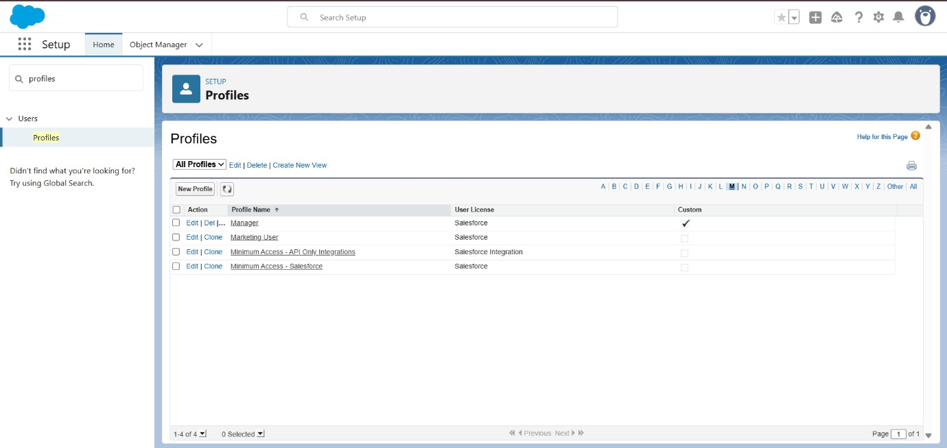

  - Click Edit to configure Custom App Settings and Object Permissions for relevant objects.
  - Adjust Session Settings and Password Policies as needed.

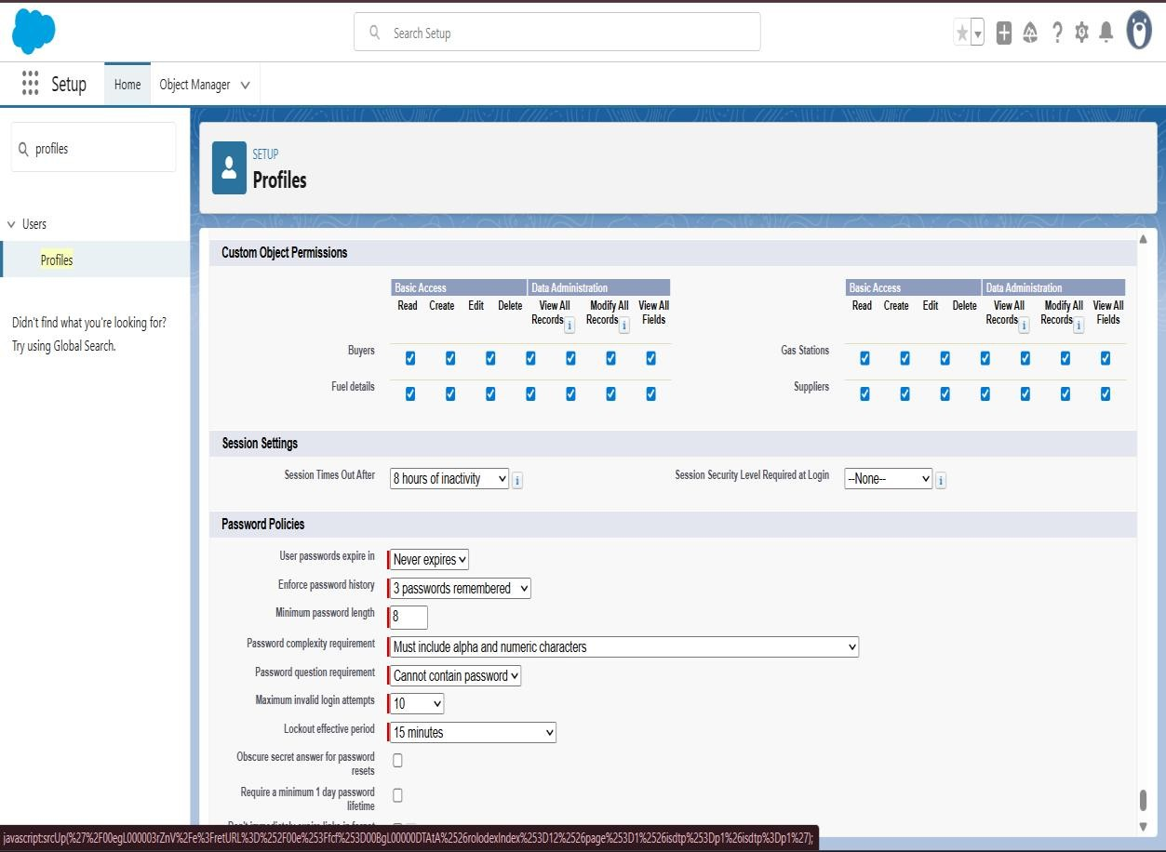

Creating Roles & Hierarchy:

  - Go to Setup → Roles → Set Up Roles → Expand All and click Add Role under the relevant parent.
  - Enter the Role Label (Manager); the Role Name auto-populates, then click Save.
  - Create Sales Executive and Sales Person roles under the Manager with the assigned profiles.
  - Ensure the hierarchy reflects reporting lines: Manager → Sales Executive → Sales Person.

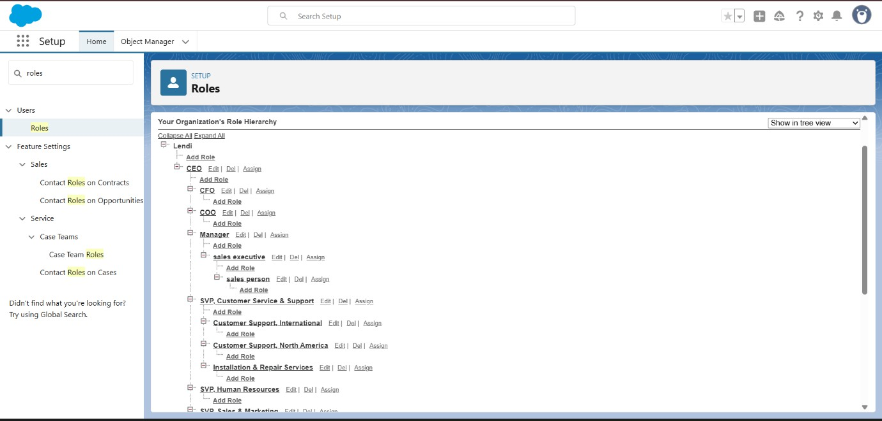

Creating users:

Users are Salesforce accounts that allow access based on role and profile.
In this project, users were created for Manager, Sales Executive, and Sales Person.
  - Exec Sales – Sales Executive
  - Mikaelson, Niklaus – Manager
  - Person, Sales – Sales Person

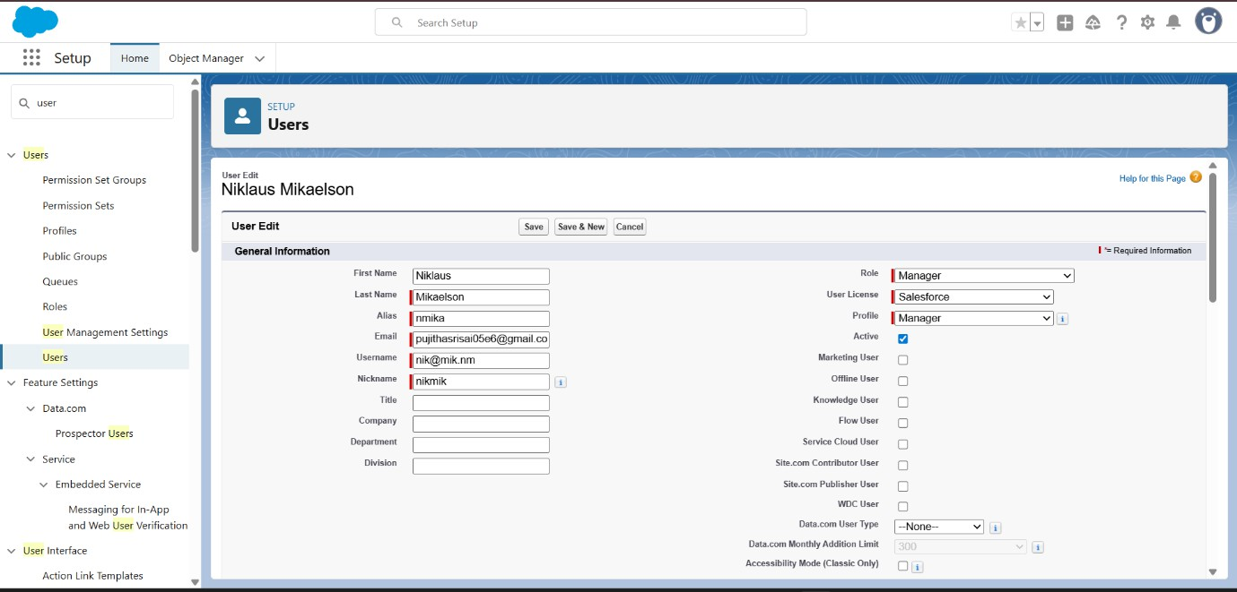

Created users the displayed

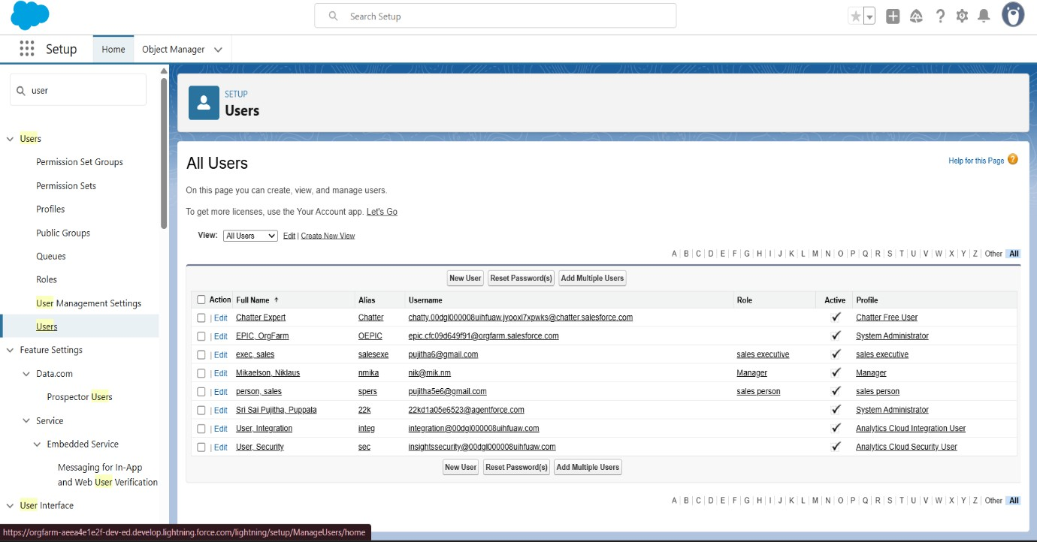

Create Permission Sets:

Permission sets extend users’ access without changing their profiles. In this project, a permission set was created to give additional access to relevant objects.
  - Assigning P1 set to sales executive.

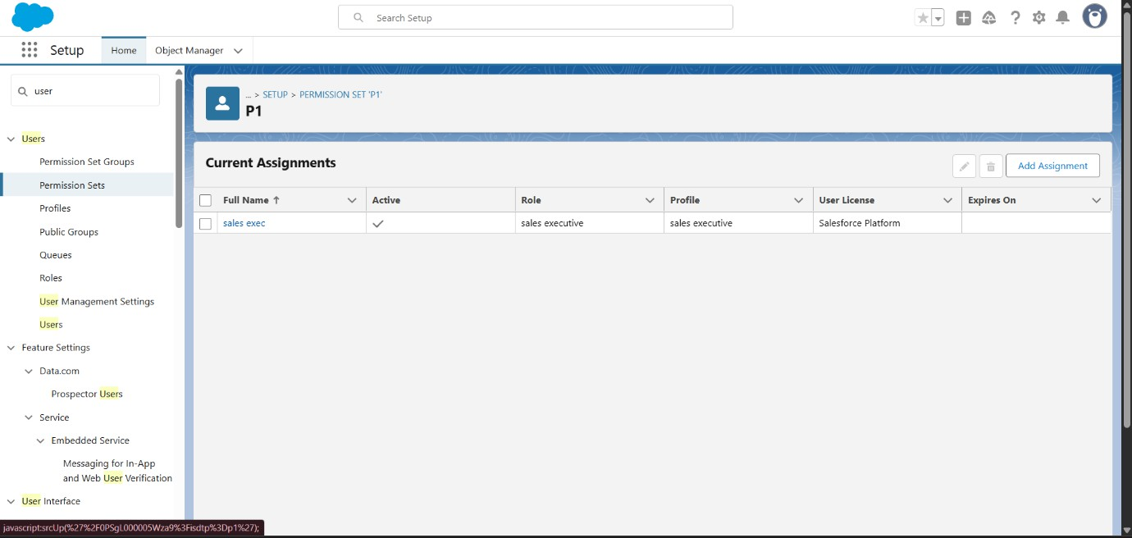

OWD (Organization-Wide Defaults)

OWD settings define the baseline level of access users have to records they don’t own.
  - In this project, Gas Station and Supplier objects were set to Public Read-Only, while roles and profiles controlled additional access.

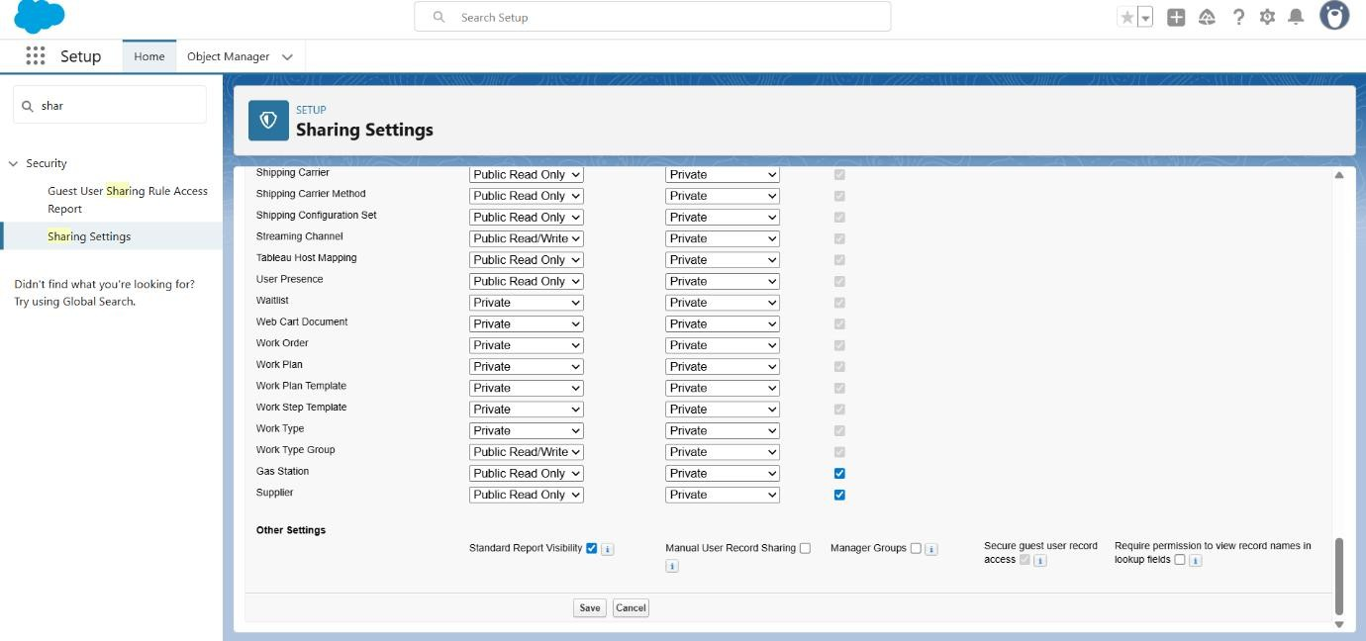

Create, View, Delete Records
User adoption measures how effectively users engage with Salesforce features.
  - In this project, creating roles, profiles, permission sets, and intuitive layouts ensured smooth usage and higher adoption of the Gas Station CRM application.

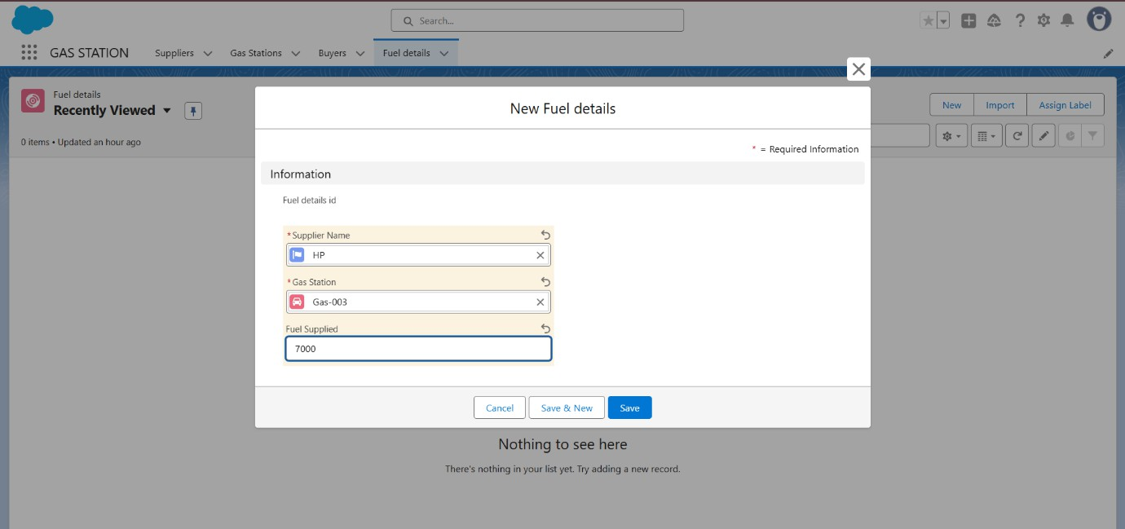

  - View record
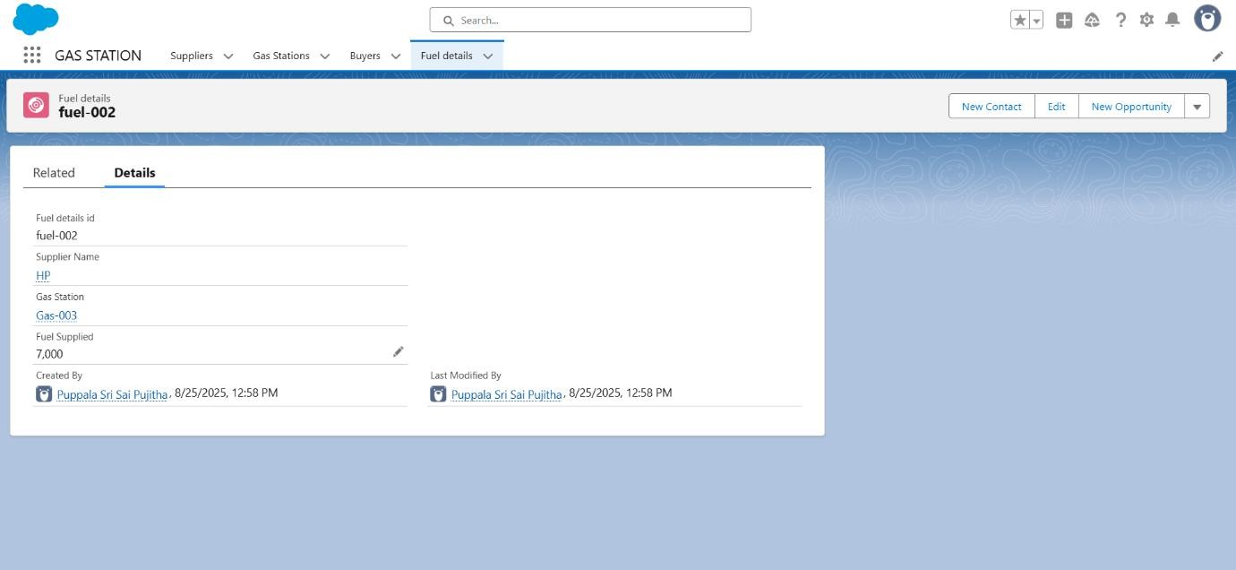

  - Delete record
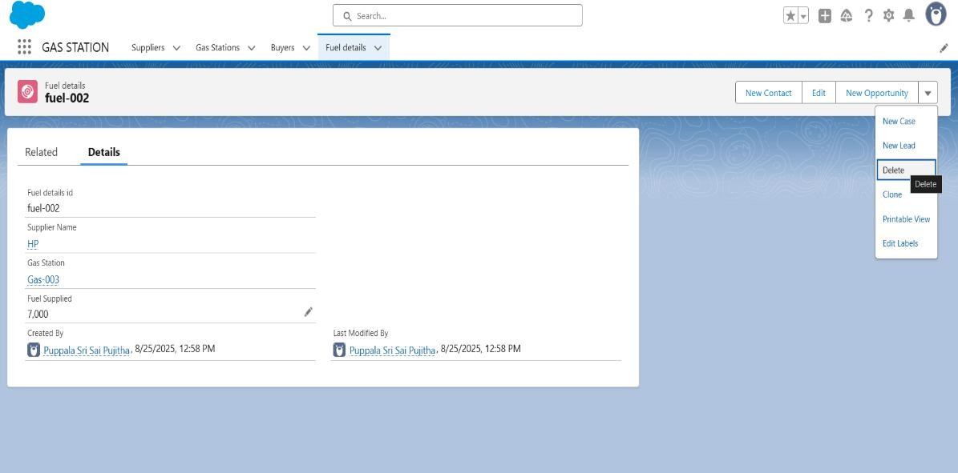

- Creating Reports

Reports are used to analyse and display Salesforce data in a structured format.
  - In this project, custom reports were created to track fuel usage, customer activity, and sales for better decision-making.

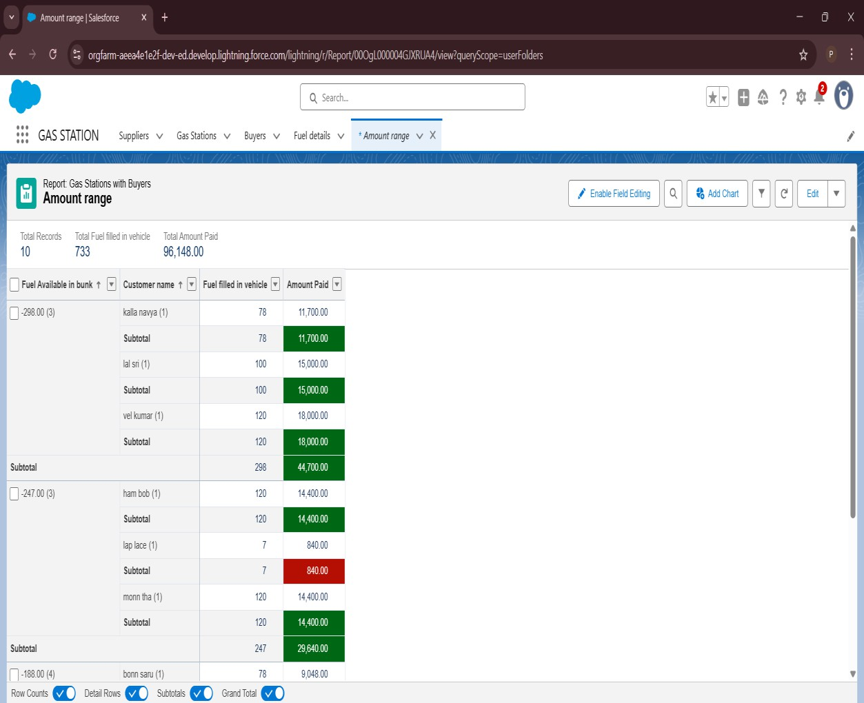

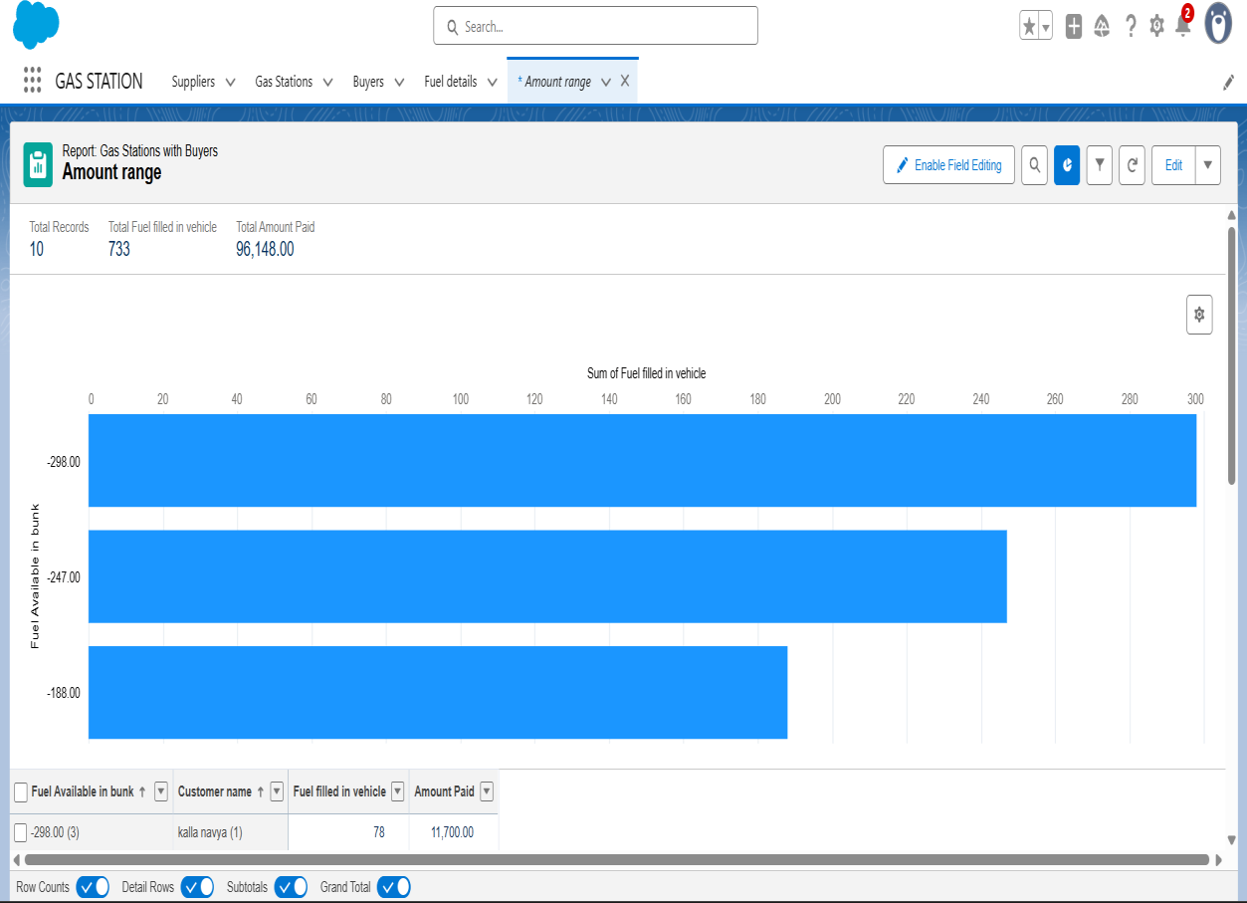

- Creating Dashboards

Dashboards visually display key metrics and report data in charts and graphs.
  - In this project, dashboards were created to provide insights on fuel estimation, sales, and customer activity

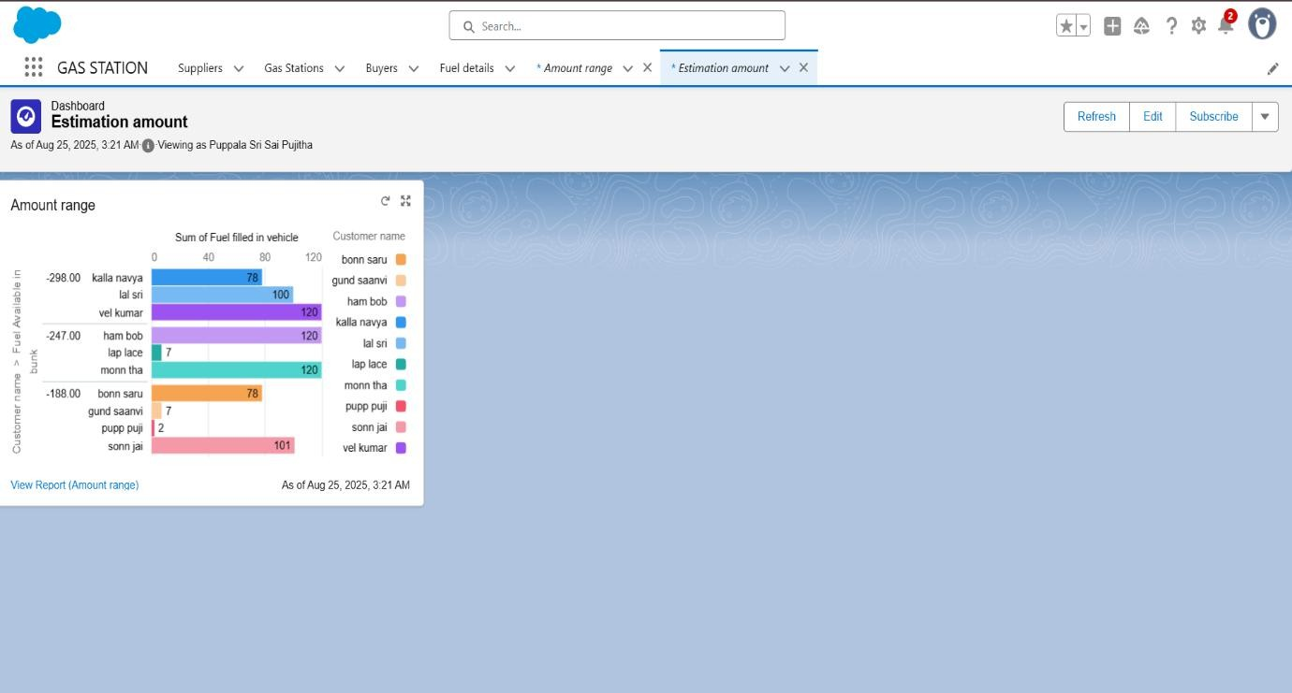

- Creating Flow

Helps in reducing manual effort and ensures quick communication with customers.
  - A record-triggered flow was created on the Buyer object.
  - The flow triggers when a record is created or updated.
  - It automatically sends an email receipt to the customer.
  - The email includes Customer Name, Amount Paid, Vehicle Type, and Fuel Intake.

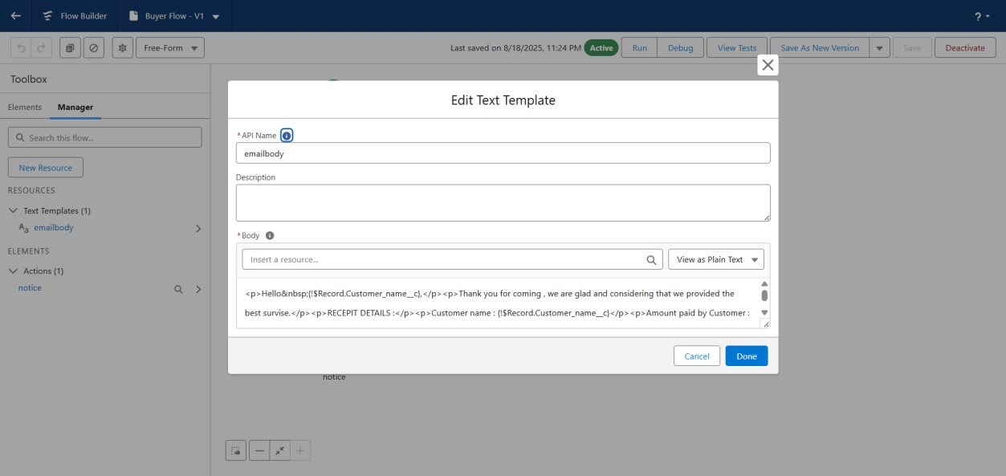

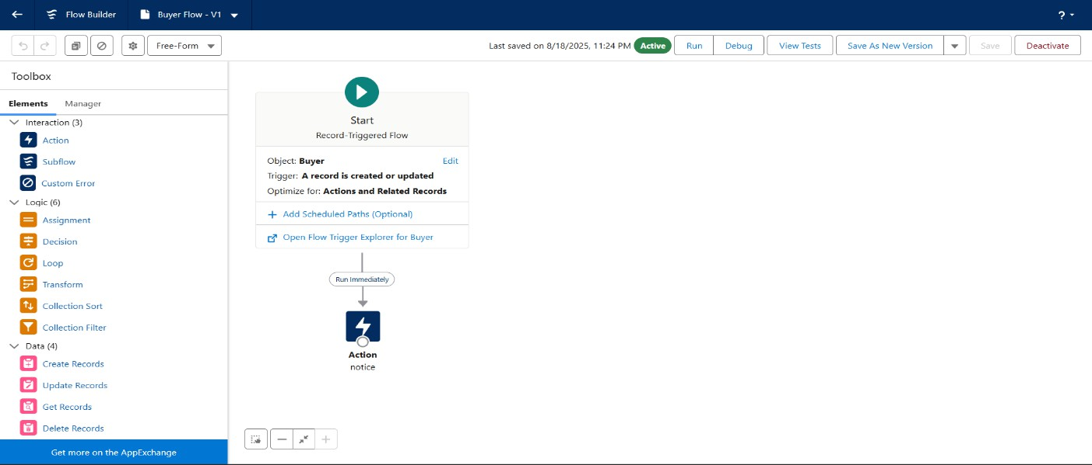

Creating Apex Triggers

Apex triggers are custom code that execute before or after events on records.
Handler (FuelRecordHandler.apxc)
  - beforeDeleteInfo → Stops deletion of Fuel Details if supplier qty > 500.
  - beforeDeleteGas → Ensures Gas Station fuel price > 50 before insert.

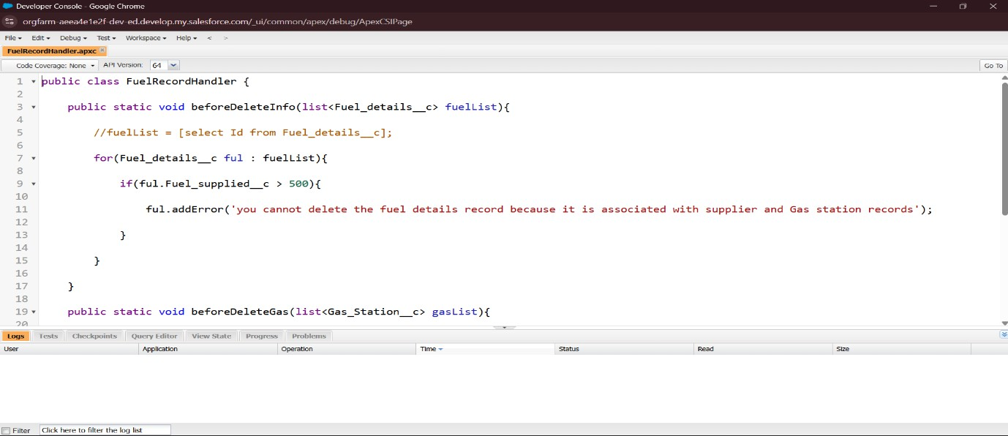

Trigger: Fuel Details (before delete)
Prevents deleting Fuel Details if linked records exist.

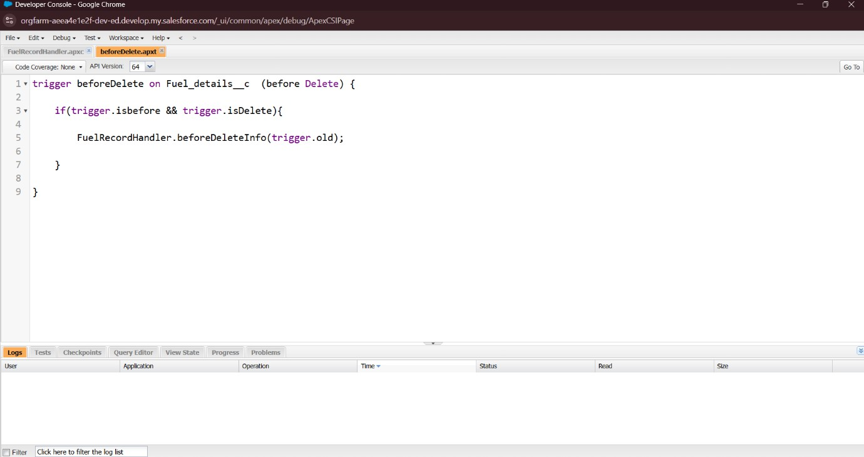

Trigger: Gas Station (before insert)
Validates fuel price before record creation.

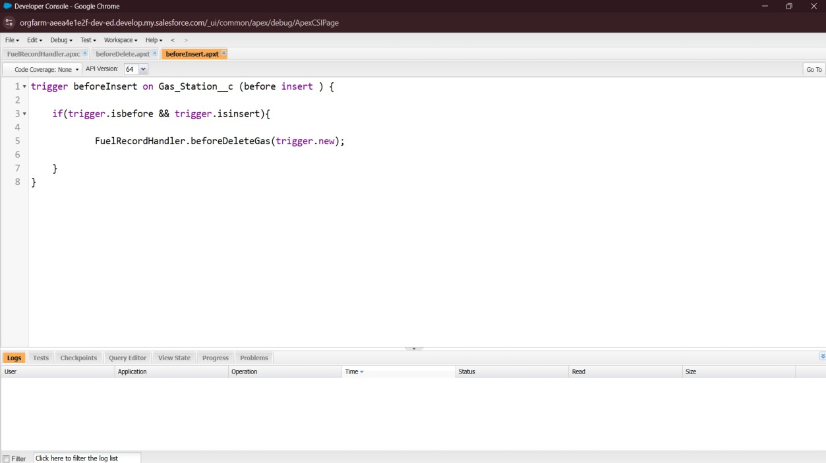

Feature Enhancements for Gas Station App:

Salesforce Einstein features like AI chatbots, predictive insights, and analytics can be
integrated into the Gas Station app to improve customer experience and business decision- making.
- Einstein Bots Integration – Enable AI-powered chatbots to answer customer queries, share fuel prices, and generate receipts automatically.
- Einstein Next Best Action – Provide personalized offers or discounts to customers based on their fuel purchase history.
- Einstein Activity Capture – Automatically log customer communications such as emails for better tracking and engagement.
- Einstein Analytics Dashboard – Visualize sales trends, supplier performance, and customer demand using advanced analytics.
- Einstein Prediction Builder – Predict customer return behaviour to support targeted marketing strategies.

Additional Screenshots:

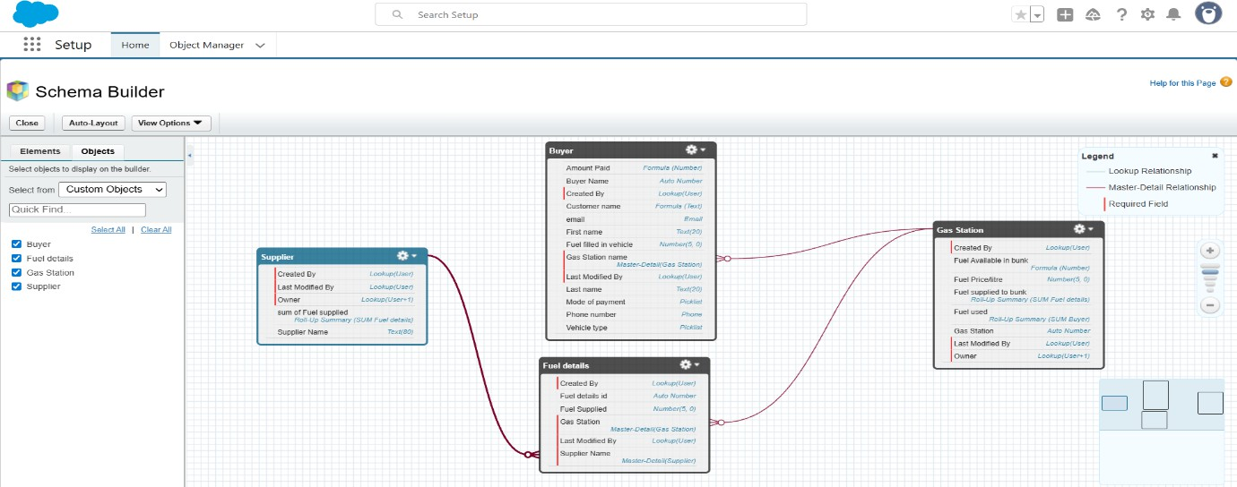
Fig: custom objects relationship


Fig: custom tabs for custom objects

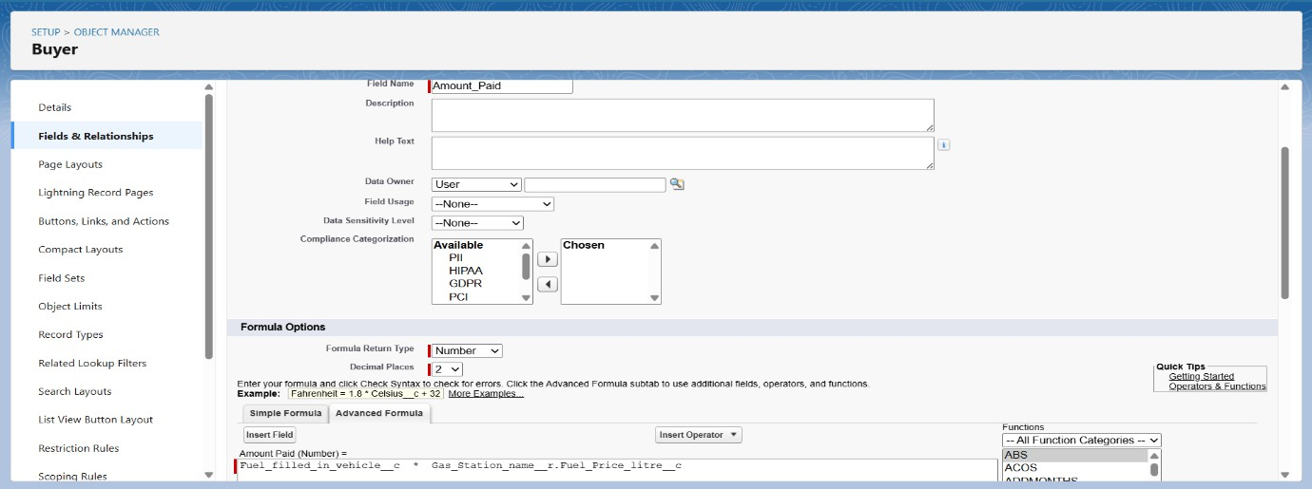
Fig: formula field of amount paid

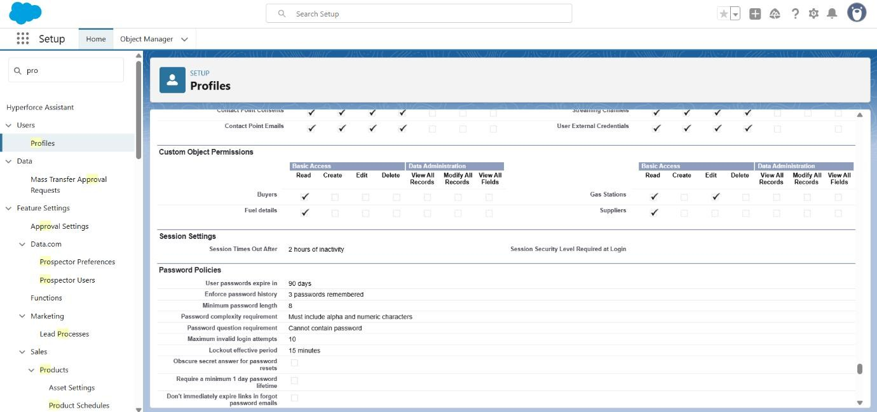
Fig: sales executive profile

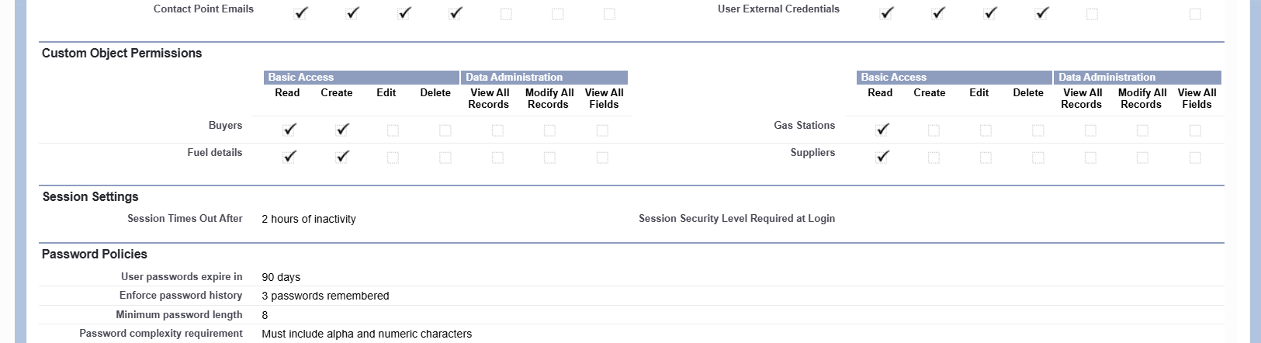

Fig: salesperson profile

Conclusion:

The Gas Station CRM project in Salesforce has been designed and implemented to cover all essential business operations, from managing buyers, suppliers, and fuel details to automating tasks using flows and Apex triggers. By creating custom objects, profiles, permission sets, and page layouts, the application ensures proper organization of data and secure access for different users such as Manager, Sales Executive, and Sales Person. Flows were designed to
send automated customer receipts and improve service, while triggers ensured data accuracy during record insertions and deletions. Reports and dashboards provided valuable insights for decision-making, helping managers monitor performance and streamline processes. Overall, the project highlights how Salesforce can be leveraged as a powerful platform to improve
efficiency, reduce manual effort, and deliver a better customer experience in gas station management.

